 | ISCG7421  Advanced Programme Development  Semester 2, 2017  Assignment 1 A – Building a Control
Computing Science Practice Pathway | Approval Deadline: 8:00 p.m. 8th August 2017  Deadline Time: 5.30 p.m.  Deadline Date: Friday 1st September 2017  Demonstration Date: Tuesday 5th September 2017  Course Weighting: 15%  Marks: 100

Assignment Aims

This is an individual assignment. This assignment is intended to help you gain experience with designing, documenting, building and testing a C# control using Windows Forms Control Library C# template. You are to design, document, and construct a control of your choice and develop a test program and a set of test cases that demonstrate and test all of your control’s features and properties. Your choice of control should be unique and be approved by the lecturer. You are advised to get lecturer approval as soon as possible; see above for the recommended deadline for approval. Please note that approval is given to any choice of control that is likely to get at least a passing grade (C- and higher).

Exclusions

Please note that, for this semester, the following controls are excluded from the allowable list of controls:
- Shape Generator, Media (audio/video) Player, Calculator
- Games: Towers of Hanoi, Tetris, Frogger, Any kind of memory game, Chess, Draughts (checkers)

Instructions

Control Design

Your control must have at least six features, three of which must contain reasonably complex functionality that accesses at least one entity class (you can receive advice on this from the lecturer). Your design should produce a control that is useful, reusable, portable and intuitive, and that utilises at least two entity classes (the entity classes do not have to be persistent but if you wish them to be then just use text files or XML).

You must produce design documentation that consists of:
- An overall explanation of what the control does (plus an explanation of the origin of your idea)
- Explanations of what each feature does (one paragraph each).
- One UML use case diagram with each feature as a use case.
- One use case narrative for each feature.
- One UML sequence diagram, for each feature, depicting the main flow.
- One UML design class diagram, for each feature, showing the interface (boundary), controller and entity classes used.
- One overall design class diagram (showing entity classes only – this has to consist of at least two classes)
Please note that the UML artefacts (i.e. use case diagram, interaction diagrams and class diagrams) that you use to depict your design are produced (using Visio 2016) in the formats that are presented on pages 5 to 9 of this document). Use case narratives must follow the format presented on page 6 of this document. In addition, your documentation must be submitted in a Microsoft Word document.

Control Implementation

Your control must use the Windows Forms Control Library C# template. All features must be designed, coded and tested completely and professionally. You must use the Interface/Controller/Entity architecture. Check the section “Programming Standards for C Sharp Courses” at the end of this document - the standards for C# programming in this section must be followed. In particular, this includes meaningfully commenting the beginning of each and every method in the standard format given in the document. 10 marks will be deducted if this is not done

Test Program

Your test program should allow you to demonstrate ALL properties, events and methods you have added to the control. You must also include a repeatable and independent set of test cases that has been filled in as each part of your control was tested.

Marking

Section | Available Marks
Development of Control |  | 70
- Documentation of control – introduction of control and explanation of the features | 10
- Design (8) and Implementation (7): Primary feature 1 | 15
- Design (8) and Implementation (7): Primary feature 2 | 15
- Design (8) and Implementation (7): Primary feature 3 | 15
- Design (3) and Implementation (2): Secondary feature 1 | 5
- Design (3) and Implementation (2): Secondary feature 2 | 5
- Design (3) and Implementation (2): Secondary feature 3 | 5
Demonstration and Testing |  | 30
- Test Program(Project) | 5
- Demonstration that shows how the implementation follows the design documentation and how the testing documentation relates to the design. | 10
- Test Cases | 15
Deductions:
Total: | 100

Do you want to do the best that you can do on this assignment and improve your grades?
You could:
- Talk it over with your lecturer
- Visit Te Pune Ako or Maia for learning advice and support
- Visit the Centre for Pacific Development and Support
- Contact the USU Advocate for independent advice
- For contact details and more information, go to www.usu.co.nz

The marks may be decreased based on problems with:
- The quality of your code and use of C#.
- Your code complying with the programming standards for the course (note the point about comments at the start of EVERY method – 10 marks will be deducted if this is not done).

Please note that if you download code from the Internet and do not reference it correctly in your code and your documentation it will be treated as plagiarism and you will receive zero marks for the assignment.

Example of referencing code:

Kanjilal, J. (2006) Working with Threads in C#. Retrieved August 17, 2011 from http://aspalliance.com/846_Working_with_Threads_in_C

Delivery

- A soft copy of all of the C# files needed to run your control and your test program and a soft copy of your design and testing documentation. Please note that you must submit your assignment in Visual Studio Community 2015. 30 marks will be deducted if this is not done.

- You are required to demonstrate your control and its relevant documentation in class – see front page for date.

Assignment Hand-in

Electronic submission of the assignment is required for ALL assignments. This copy must be submitted on Moodle prior to 5:30 p.m. on the due date.

Assignments submitted after the due date and time without having received an extension through Special Assessment Circumstances (SAC) will be penalised according to the following:
• 10% of marks deducted if submitted within 24hrs of the deadline
• 20% of marks deducted if submitted after 24hrs and up to 48hrs of the deadline
• 30% of marks deducted if submitted after 48hrs and up to 72hrs of the deadline
• No grade will be awarded for an assignment that is submitted later than 72hrs after the deadline.

Special Assessment Circumstances

Students who, due to circumstances beyond their control, miss an assignment deadline or consider their performance in an assignment to have been adversely affected, should complete the form available from any Student Services Office. You need to submit the form and a medical certificate or documentary evidence that shows the circumstances were beyond your control. You have a maximum of five working days to submit the SAC application.

When applying for an SAC for an extension to an assignment you need to submit the assignment work completed so far on the day that the assignment is due. The extension period for which you are applying cannot be greater than the time frame on the documentation you submit. For example, a Doctor's Certificate stating you are sick for two days will entitle you to a maximum of a two-day extension.

Assistance to other Students

Students themselves can be an excellent resource to assist the learning of fellow students, but there are issues that arise in assessments that relate to the type and amount of assistance given by students to other students. It is important to recognise what types of assistance are beneficial to another’s learning and also what types of assistance are unacceptable in an assessment.

Beneficial Assistance

- Study Groups.
- Discussion.
- Sharing reading material.
- Testing another student’s programming work using the executable code and giving them the results of that testing.

Unacceptable Assistance

- Working together on one copy of the assessment and submitting it as own work.
- Giving another student your work.
- Copying someone else’s work. This includes work done by someone not on the course.
- Changing or correcting another student’s work.
- Copying from books, Internet etc. and submitting it as own work. Anything taken directly from another source must be acknowledged correctly: show the source alongside the quotation.

Test Cases
- Please using the following format for your test cases.

Requirement to test | Test Data Input | Expected Outcomes | Actual Outcomes

Deadline Date
- Please note that the deadline date is on the Friday prior to the demonstration date due to the policy regarding late submissions.

UML Examples

Domain Description: Media Sales

Media Sales wants a new computerized system to keep track of its advertising campaigns. The two members of staff at Media Sales who will use the system are the campaign manager and the accountant.

The accountant should be able to print a campaign’s invoice.

The campaign manager should be able to create a campaign, add staff to a campaign, add an advert to campaign, print a campaign’s summary and check a campaign’s budget. Three of these tasks (add staff to a campaign, add an advert to campaign, and check a campaign’s budget) should include the ability to find a current campaign. The campaign manager, while checking a campaign’s budget, needs to have an option to print the campaign’s summary and needs to have an option to print the campaign’s invoice.

Below is the use case diagram (created in Visio 2016 using the UML Use Case Template) that models the media sales domain description above:
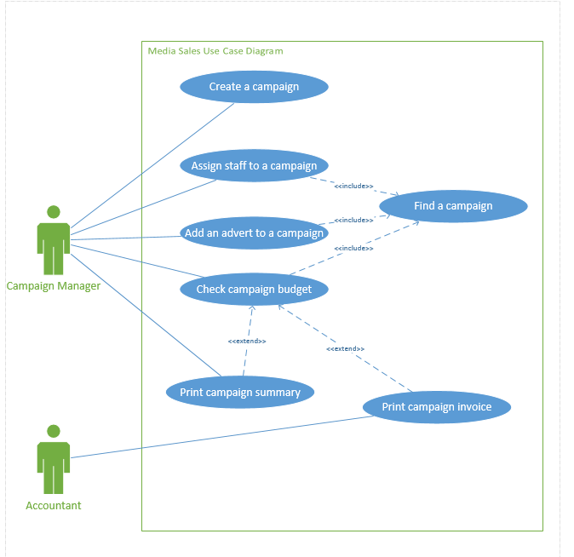
Use Case Narrative Example

Narrative for the ‘Loan Book’ use case:

USE CASE NAME: | Loan Book | USE CASE TYPE
USE CASE ID: | 6 | Design: ☑
PRIORITY: | High
PRIMARY BUSINESS ACTOR: | Loans Clerk
OTHER PARTICIPATING ACTORS: | None
DESCRIPTION: | This use case describes a loans clerk creating a loan on a book for a member of the library.
PRE-CONDITIONS: | The loans clerk has logged onto the system.
TYPICAL COURSE | - The loans clerk selects the loan book function.  - The system displays the prompt for a member ID.  - The loans clerk enters the member’s ID.  - The system retrieves the member’s details (last name and first name) and displays the member’s name (last name and first name).  - The system displays the prompt for a book ID.  - The loans clerk enters the book’s ID.  - The system then retrieves and displays the book’s details (title and author).  - The loans clerk confirms the loan of the book.  - The system creates a load record, populates it with member id, book id and today’s date, and sets the book’s status to ‘on loan’.  - The system will display a message with an indication of success.  - The loans clerk clicks on exit to end the use case.
OF EVENTS:

ALTERNATE COURSES: | 3a.1 The loans clerk cancels the operation  3a.2 Go to step 11
ALTERNATE COURSES: | 5a.1 The loans clerk cancels the operation  5a.2 Go to step 11
11a.1 The loans clerk elects to loan another book for the same member
11a.2 Go to step 5
POST-CONDITION: | None
ASSUMPTIONS: | None

Narrative for the ‘Memorise Words’ use case:

USE CASE NAME: | Memorize Words | USE CASE TYPE
USE CASE ID: | 1 | Design: ☑
PRIORITY: | High
PRIMARY BUSINESS ACTOR: | Student
OTHER PARTICIPATING ACTORS: | Teacher
DESCRIPTION: | This use case describes a student studies and memorizes the word list given by the teacher.
PRE-CONDITIONS: | There is a initial word list in the application data set already.
TYPICAL COURSE | - The teacher select the user mode: teacher.  - ?????the teacher can check the student test result.????  - The application form shows the text box of word and meaning as well as the buttons for adding and saving.  - The teacher input a new word and its meaning, then click the add button and save button.  - The teacher exit the application.  - The student select the user mode: student  - The student input his or her name.  - The student select the study mode.  - The application form displays the “show word”button  - The student click the “show word”button.  - The application form display the word and its meaning in word box and meaning box respectively at the same times  - After studying all of the words The student select the test mode  - The student click the “show word”button.  - A word will be displayed without its meaning  - The student recall its meaning, and then click “show meaning ” button.  - After reading the correct meaning, the student click “success” button or “fail” button according to his or her recalling result.  - ??????? reviewing result....  - ???????filter the words the student has already been familiar with.  - ?????? button disabled
OF EVENTS:

ALTERNATE COURSES: | The teacher can repeat the step XXX to XXX more than 1 times to add several new words.
ALTERNATE COURSES: | The student may repeat the step xxx to xxx more than 1 times to study the words list.
 | In the self-testing stage, the student may repeat the step xxx to xxx more than 1 times.
POST-CONDITION: | None
ASSUMPTIONS: | None

UML Sequence Diagram Example

Rules:
- One Interface Class for each external actor involved in the use case
- One Controller Class per use case
- As many Entity Classes as needed to perform the use case
- Show attributes and operations (methods)
- Interface Object(s) interact with Controller Object and Actor only
- Controller Object interacts with Entity Object(s) and Interface Object(s)
- Entity Object(s) interact with other Entity Object(s) and the Controller Object

Below is the sequence diagram (created in Visio 2016 using the UML Sequence Template) that models the use case narrative on the previous page:

Use Case No. 6: Loan Book
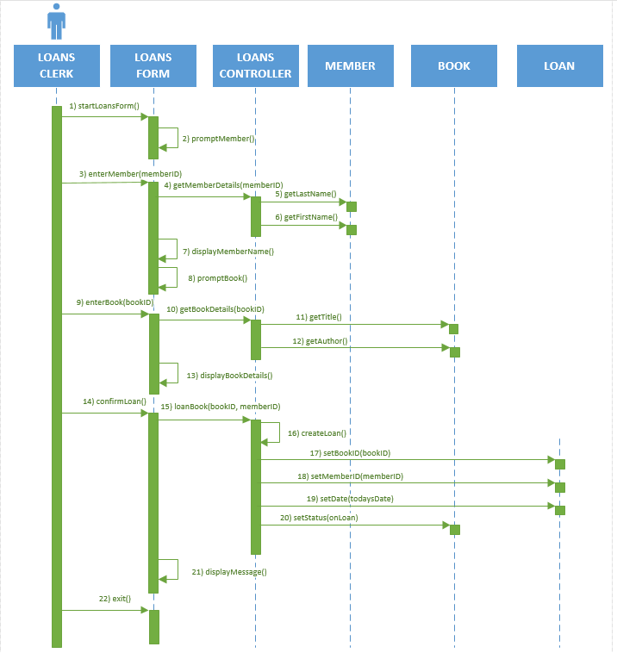

Design Level Class Diagram Example

Below is the design level class diagram (created in Visio 2016 using the UML Class Template) that models the Loan Book use case:

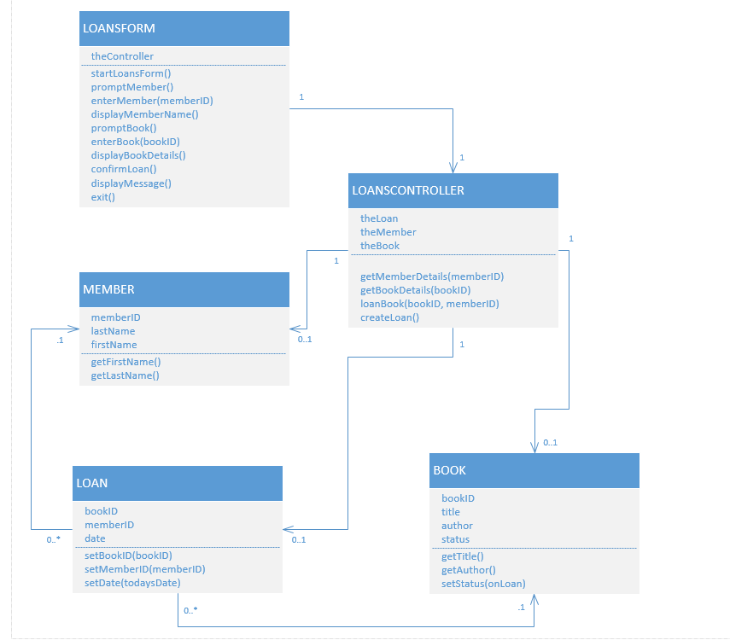

Overall Class Diagram Example

Below is an example of an overall class diagram (created in Visio 2016 using the UML Class Template):

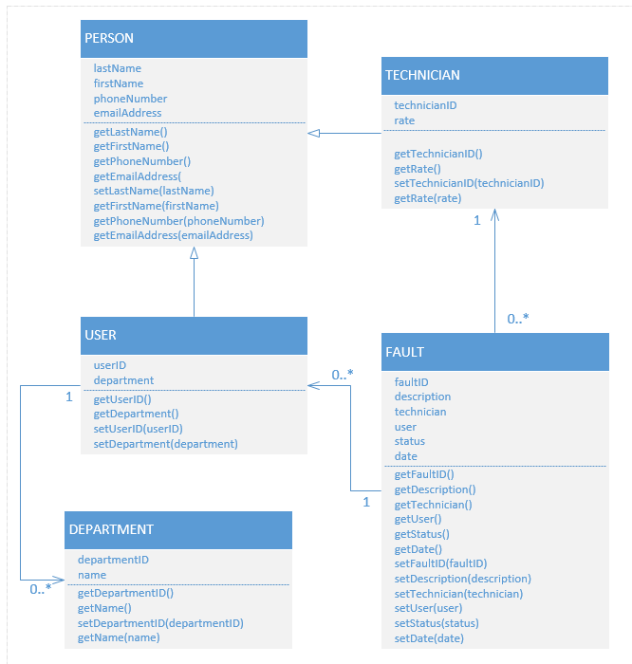
Programming Standards for C Sharp Courses
Error: Reference source not found
User Interface
- Always provide the user with clear instructions explaining what they should do. Areas used for input must be labelled to explain what input is required. Use hints or tool tips to explain interface features.

- The user must be prevented from entering values or taking actions that the program is unable to deal with. All input should be validated; any errors found should be reported back to the user with an error message which clearly and politely explains how to correct the error. The user should be unable to proceed without correcting invalid input.

Internal Documentation

- Your code is such that other programmers can read it without struggling and your users are not left guessing as to what to do.
- Each class file (including form classes) will begin with comments explaining the purpose of the class, the author and the date written.
- Each method will start with comments that explain what the method does.
- Any code which does not have an obvious meaning or which uses a specialized technique is to be commented. Use blank lines and further comments to identify where parts of a task begin within a method.
- Code will use meaningful variable, class and method names. Components which have event handler code for any of their events must have meaningful names, Components which have properties assigned to in code must also have meaningful names. A naming convention that identifies the type of component involved is recommended. E.g. btnExit, txtStartDate, lblTotal

Layout

- Code will be laid out in the style of the example below, using indentation steps of 4 spaces. Blocks using { and } will use the layout shown here:

///<Summary> method : btnLeapYear_Click
///Check if a date falls in a leap year
///</Summary>
private void btnLeapYear_Click(object sender, System.EventArgs e)
{
DateTime aDate = getDate();
if ( DateTime.IsLeapYear(aDate.Year) )
{
label6.Text = aDate.Year.ToString() + " IS a leap year";
}
else
{
label6.Text = aDate.Year.ToString()
+ " is NOT a leap year";
}
}

- Parentheses and spaces will be used to make the meaning clear in arithmetic expressions and conditions.
sum = (n1 / n2) + n3;
not
sum = n1 / n2 + n3;
nor
sum=n1/n2+n3;

- In general each method will perform a single simple task.
- In the final version of your project please delete all sections of code that have been ‘commented out’.

